Supplies needed for a
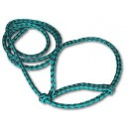Lamb halter
Feeder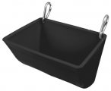
lamb owner:

- Water bucket with clip
- Feeder with clips
- Pine shavings - you will need to clean out pens at least every other week.
- Lamb halter
- Lamb blanket
- Muzzle
- Antibacterial soap – this can be liquid dish soap, the cheap stuff will do, it is just for washing before you shave your animal
- Feed
- Hay – alfalfa, one small handful a day
- Official FFA Jacket – order from National FFA.org
- Show Official Dress –
  - Black pants – jeans or dress pants
  - White collared shirt
  - Solid black boots or shoes
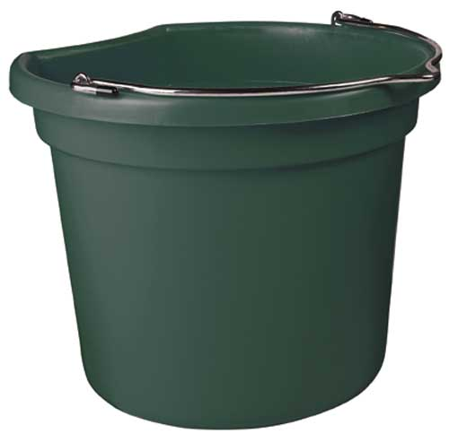
Water Bucket

Type of clip others can be used.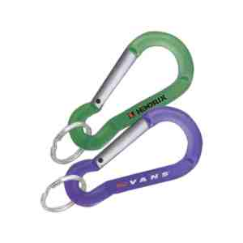

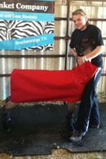 Lamb Blanket 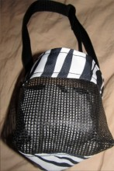 Muzzle

